High School Students’ Growth in EFL Vocabulary Size Estimated By Vocabulary Quotient

Hong-Fa Ho*
Department of Applied Electronics Technology, National Taiwan Normal University, Taipei 10610, Taiwan, R.O.C.
jackho@ntnu.edu.tw

Abstract: Insufficient English vocabulary size accounted for one of the common learning problems in EFL students. Some researchers identified vocabulary growth as another challenge for EFL students. This study tends to compare vocabulary test scores between junior and senior high school students, and use the score difference to estimate students’ growth in vocabulary size. To convert the raw data of the student test scores to an indicative vocabulary size measure for teaching and learning purposes, this study applied a key performance indicator method called Vocabulary Quotient (VQ) to estimate participants’ vocabulary size. A total number of 1938 participants were selected from 276 different high schools to contest in a National Spelling Competition in 2010 in Taiwan. The completion was an English vocabulary test consisted of three test models of spelling, reading, and listening. The targeted vocabulary were based on 2200 and 7000 words from National vocabulary recommendations. The findings included: (1) the vocabulary size of EFL students in spelling, reading, and listening increased 3591, 4328, and 4206 words, respectively. The mean growth had close to but no more than 4800 words that are recommended to study from junior to senior high schools; (2) spelling had the least growth in vocabulary size; (3) reading had the most growth in vocabulary size. The results indicated despite the mean value of the participant’s vocabulary size had achieved up to 80 percent of the national recommendations, there is still large English proficiency gaps among high school students. The results shown EFL high school students in Taiwan had about one-fourth vocabulary size compared to native English speakers and nearly half vocabulary growth rate of the bidialectal English speakers. The findings have provided an insight that the vocabulary growth size of EFL high school students in Taiwan was highly affected by the national recommended vocabulary. It is suggested the policy makers may consider not only the learning burden of the lower English proficiency students, but also an encouraging environment for higher achieving students.

Keywords: English as a Foreign Language (EFL); vocabulary quotient (VQ); vocabulary test; vocabulary size

- INTRODUCTION
There are more than one billion people learning English as a Foreign Language (EFL) globally . In many countries, English also became an official language or considered as an educational priority in school curriculums . Most high school students proceeding to university studies, the abilities often required are doing online research, reading English textbooks, and literatures. According to , English vocabulary is one important contributing factor for good English proficiency. Therefore, sufficient vocabulary size is important in acquiring English language skill. has suggested several viewpoints on vocabulary growth. At first, vocabulary growth is influenced by individual’s knowledge of the world, especially in various disciplines and technical vocabulary. Second, a good vocabulary growth strategy required broad vocabulary knowledge. Third, teacher plays an important role in direct teaching of high frequency vocabulary to indirect encouragement of low frequency vocabulary.

Since reading and listening are major ways for communication and knowledge transmission, both are considered as major sources for English vocabulary acquisition and evaluation methods. Study suggested that individual’s reading ability has reciprocal effect with one’s vocabulary ability which was explained by Matthew’s reading effect . Others suggested 1000 learned vocabulary contributed to 72% of reading text coverage and 15851 vocabulary contributed to 97.8% text coverage . Listening is another required ability in a real life English conversation . Although dialogue questions are often used to assess students’ listening comprehension, some were without the features of pronunciation , and some of the tested word needs to be audio recognized . There are limited studies included proven listening test model in the vocabulary assessment tools. Ho and Lin, therefore, adopted the concept of Chinese character quotient with a listening test model in an English vocabulary test in this study.

Many English vocabulary assessment tools were studied for the learner’s English language skill including Vocabulary Levels Test ; Eurocentres Vocabulary Size Test ; and V-Size concept with computer software , where the e-rater software measured the learner’s vocabulary size and writing ability . Most vocabulary assessment tools tested on learners’ English spelling, recognition, and usage . Yes/No type question accounted for a small number of word recognition tests was criticized by its high 50-50% guess rate, multiple choice question as a better alternative was then suggested . Consequently, studies have concerned the problem of unusable scores after the English vocabulary tests and started to consider a more effective measurement of the learner’s vocabulary state . Ho and Huong, on the other hand, adopted an estimation tool named vocabulary quotient (VQ), which is one kind of KPI (Key Performance Indicator) assessment tool in EFL teaching and learning . VQ is different from other assessment tools. VQ enables to estimate English vocabulary size from test models of keyboard spelling, audio listening, and visual reading in a computer vocabulary test. This study compared the test scores between junior and senior high school students in Taiwan. The scores then converted by VQ formula resulted in a more precise vocabulary size measure. The correct estimate of vocabulary size is able to give a simple and standardized comparison between groups as well as a tool for future teaching and learning evaluation.

Three research questions were considered:
Q₁: What is the growth in vocabulary size between junior and senior high schools in three test models of spelling, reading, and listening?
Q₂: What is the least growth in vocabulary size in three test models of spelling, reading, and listening?
Q₃: What is the most growth in vocabulary size in three test models of spelling, reading, and listening?

The Ministry of Education in Taiwan recommended a list of English 2200 vocabulary which is a lexicon for junior high school textbooks. For senior high schools, English 7000 vocabulary was recommended by College Entrance Examination Center in Taiwan. High school curriculum and textbooks are based on the recommended vocabulary list, therefore, it is our intention to examine the effects of the recommendation list on students’s vocabulary size. In other words, the students may be susceptible to 4800 words learning constraint studying from junior to senior high school level. The National Spelling Competition was held every year to test on Taiwanese students’ vocabulary proficiency at all school levels. Junior and senior high schools are two test groups of the interest in this study, therefore, the test results of both groups were used to compare their growth in vocabulary size. Junior high school students were tested on 2200 words and senior high school students were tested on the 4800 words difference by subtracting 2200 from 7000 recommended words. By comparing the test results between groups and estimating the growth in vocabulary size with VQ method, this study proposed H_{1.} H₂ was proposed due to the study’s spelling test required more memory to spell a word than reading and listening test to select a multiple choice answer. In terms of H₃, reading has the most growth in vocabulary size was hypothesized based on the English learning environment in Taiwan: (1) students are taught in the Chinese speaking and listening classrooms; (2) listening has the least amount of practice time compared to spelling and reading; and (3) reading is taught in English paragraph and has longer study time than listening. Hence, the author proposed reading has the most growth in vocabulary size.

Three hypotheses are proposed:
H₁: The growth in vocabulary size is less than 4800 words between junior and senior high schools in three test models of spelling, reading, and listening.
H₂: Spelling has the least growth in vocabulary size in three test models of spelling, reading, and listening.
H₃: Reading has the most growth in vocabulary size in three test models of spelling, reading, and listening.

- METHOD
  - Participants
A total number of 1938 participants contested in a 2010 National Spelling Competition in Taiwan. The students were selected from 276 different high schools, including 1156 students from 169 junior high schools and 782 students from 107 senior high schools. Table I shows the grade composition and the number of students of two test groups. To enter the competition, English teachers of each school recommended students with good English proficiency with class attendance of more than three years for junior high and more than five years for senior high school students.

TABLE II PARTICIPANTS OF TWO TEST GROUPS (N=1938)
Test Group | Junior High | Senior High
Grade | Grade 7th~9th | Grade 10th~12th
n | 1156 | 782

  - Materials
2010 National Spelling Competition was held to test junior high school students on English 2200 vocabulary and to test senior high school students on 4800 words (subtract 2200 from 7000 recommended words). The competition is a computerized test that consisted of three test models: (1) spelling, (2) reading, and (3) listening. Each test model has 100 questions with a total model point of 100. The computer randomly selected 300 test questions without repetition. The test scores were then examined with the VQ method to estimate the students’ growth in vocabulary size between two test groups. The VQ method is based on a VQ formula: (VQ (p, m, L, t, z) = {VQ_{i} | 1< i < d}) in , where the test score is converted to a vocabulary size estimation.

  - Tools
An English vocabulary test software is comprised of three test models (Table III): (1) spelling, (2) reading, and (3) listening test. Test model symbols were denoted as the following: (1) E_{t} is a target English vocabulary; (2) E_{x}, E_{y}, and E_{z} are non-target English vocabulary, x≠y≠z≠t; (3) C_{p} (E_{t}) is a corresponding Chinese meaning of the E_{t}; (4) V (E_{t}) is an English pronunciation of the E_{t}; (5) Len (E_{t}) is a length of the E_{t}, which is the number of letters used to spell the target English word.

In spelling test, students spell out and type in the target English vocabulary after pronunciations are given. In reading test, students choose correct vocabulary in multiple choice questions. In listening test, students are tested on the target English vocabulary and listening comprehension in multiple choice questions.

TABLE IV THREE TEST MODELS OF ENGLISH VOCABULARY TEST
Test Model | Description
Spelling test | Given C_{p} (E_{t}), Len (E_{t}), and V (E_{t}).  Examinee is asked to key-in E_{t}.
Reading test | Given E_{t} and the choices of C_{p} (E_{t}), C_{q}, C_{r} and C_{s} in random sequence. C_{p} (E_{t}) was the target choice, and C_{q}, C_{r} and C_{s} were the wrong choices.  Examinee was asked to choose the target choice.
Listening test | Given V (E_{t}) and the choices of C_{p} (E_{t}), C_{q}, C_{r} and C_{s} in random sequence. C_{p} (E_{t}) was the best choice which matched the given V (E_{t}). C_{q}, C_{r} and C_{s} were the wrong choices.  Examinee was asked to choose the target choice.

The Statistical Package SPSS v.18 was used. The descriptive statistic provides mean score and standard deviation of the three tests.

  - Design
The study is a two factorial design to examine the recent English vocabulary growth size among junior and senior high school students by comparing three test scores of spelling, reading, and listening. The VQ method was used to estimate the vocabulary size of the each test score (0-100 points).

  - Procedure
The study was conducted with 2010 National Spelling Competition in Taiwan. Participants contested in a computer English vocabulary test program designed by the author. Before the tests, all participants were asked to familiarize with test devices such as earphones and computer softwares in a computer room. 300 questions of three test models were randomly asked in an order of spelling, reading, and listening. 100 questions from each model required finish time in 20, 10, and 10 minutes for spelling, reading, and listening, respectively. The test scores were analyzed by the computer software with the VQ method for the vocabulary size estimation.

- RESULTS AND DISCUSSION

The test score is presented in a horizontal axis and number of participants is on a vertical axis (Figure 1 and Figure 2). Distribution curves of the model scores were all negatively skewed in both Figure 1 and Figure 2. The histogram distributions indicated the majority of students were above average scores of the English vocabulary test in spelling, reading and listening.
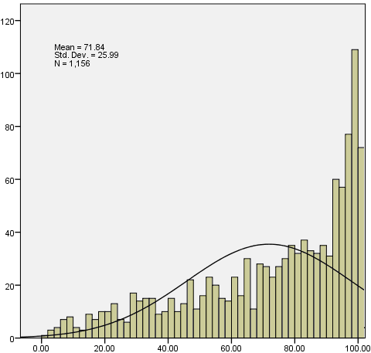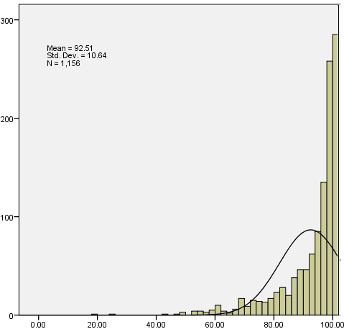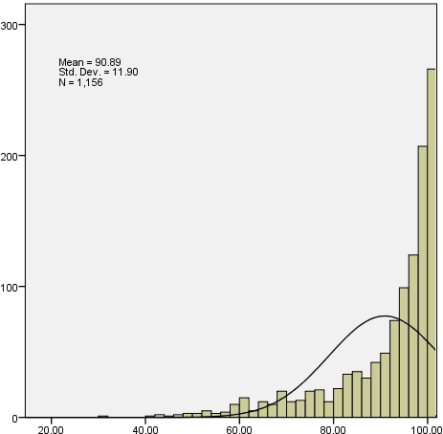
(a) Spelling. (b) Reading. (c) Listening.
Fig. 1 Histogram distribution of the test model scores for junior high

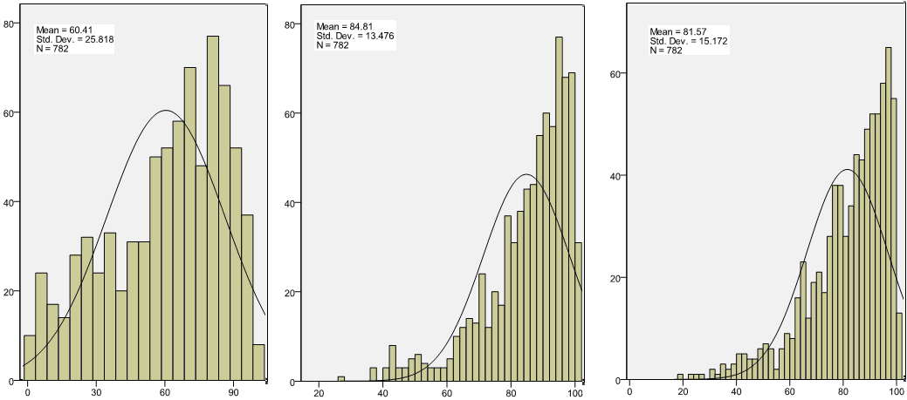
(a) Spelling. (b) Reading. (c) Listening.
Fig. 2 Histogram distribution of the test model scores for senior high

Table V summerized the calculated mean and standard deviation (SD) for two test groups. The mean scores of the three tests in descending order are 93-85 points in reading, 91-82 points in listening and 72-60 points in spelling. Spelling had the lowest mean scores and twice SD (26 points) than reading and listening (13 points).

TABLE VI MEAN VOCABULARY TEST SCORE (IN POINTS) OF THREE TEST MODELS
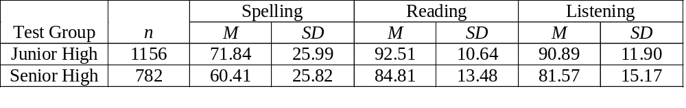After comparing the test results, the author used the VQ method to estimate minimum, maximum, and mean vocabulary size of the participants shown in Table VII. The mean difference between junior and senior high test groups was subtracted to give a growth in vocabulary size. The growth sizes were estimated to be 3591, 4328, and 4206 in spelling, reading, and listening, respectively. The estimated sizes were about one-fourth of native speakers who has comparatively high 20,000 vocabulary in tertiary education . Because the growth size of EFL students in spelling, reading, and listening were less than 4800 words, the study hypothesis H₁ was supported. H₂ and H₃ are separately supported by the findings that spelling had the least growth in vocabulary size and reading had the most growth in vocabulary size. The growth rate of spelling, reading, and listening were also calculated to about 1197, 1443, and 1402 words per year, respectively. The mean growth rate was compared half to the bidialectal speakers of Hawaiian Creole Engish and standard English, who had a growth rate of more than 3,000 vocabulary per year .

TABLE VIII MEAN VOCABULARY SIZE (IN WORDS) ESTIMATED BY VQ
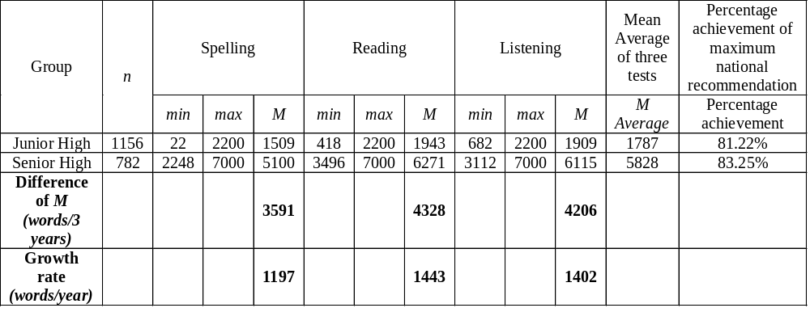Figure 3 used boxplot graphic to present the different estimated VQ value of vocabulary size in spelling, reading, listening between two test groups. The bottom line, the upper line, and the middle point represents the minimum, the maximum, and the mean of the estimated vocabulary size among the participants. The findings suggested that the participants had general better vocabulary performance and had a growth difference of about 200 words per year in reading and listening greater than spelling. Large vocabulary size gaps between individuals also existed in all aspects of spelling, reading, and listening.

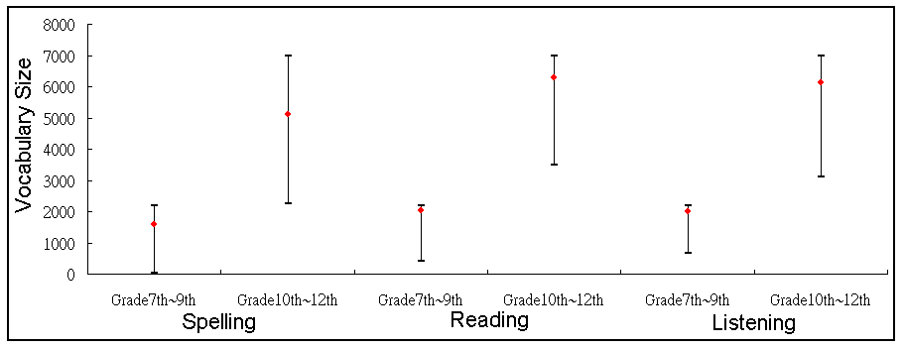
Fig. 3 Min, max, and mean of vocabulary sizes of three aspects between two test groups

- CONCLUSION

The study evaluated students’ vocabulary acquisition provided that the high school curriculum and textbook were based on the national recommended vocabulary from The Ministry of Education (English 2200 vocabulary in junior high) and College Entrance Examination Center (English 7000 vocabulary in senior high) in Taiwan. The findings contributed to educational applications in vocabulary size theories and practices. Vocabulary quotient can be used as a useful key performance indicator in English vocabulary teaching and learning.

Using VQ as a key performance indicator, EFL teachers can identify early if the student had insufficient vocabulary size. By calculating the VQ formula, teachers are able to evaluate the student’s vocabulary sizes before, during or after the school curriculum. By quickly accessing the individual vocabulary size, teachers are able to adjust the course curriculum and pace to fit to the student’s needs. These research findings can also be compared with other EFL or language learning groups in other regions or countries in the growth of English vocabulary. This study results shown EFL high school students in Taiwan had about one-fourth vocabulary size of the native English speaker and about half the vocabulary size growth rate of the bidialectal English speaker.

The study validity needs further approval by including larger population size and further improvement by adding speaking assessment for future research. Despite the mean value of the participant’s vocabulary size had achieved up to 80 percent of the national recommendations, there is still large English proficiency gaps among high school students, as seen in Figure. 1, 2, and 3. The wide standard deviation indicated the Matthew effects existing in the study’s participants , namely, the reciprocal effects were strong between the insufficient size in vocabulary and the English achievement in reading. Therefore, the insufficient vocabulary size may have restricted the participants’ continuing English acquisition. The participants also had a lower vocabulary growth in spelling than reading and listening, English teachers may consider strengthening the students’ weakest area, which is spelling in this case.

The findings have provided an insight that the vocabulary growth size of EFL high school students in Taiwan was highly affected by the national recommended vocabulary. It is suggested the policy makers may consider not only the learning burden of the lower English proficiency students, but also an encouraging environment for higher achieving students with more than one vocabulary recommendation list in order to escalate the upper bound on the vocabulary growth in national student population.

ACKNOWLEDGEMENTS
This work is partially supported by the “Aim for the Top University Project” from National Taiwan Normal University, the Ministry of Education, Taiwan, R.O.C., and National Science Council (NSC 101-2511-S-003-046).

REFERENCES
[1] M. Clyne and F. Sharifian, "English as an international language: challenges and possibilities," Australian Review of Applied Linguistics, vol. 31, 2011.
[2] W. Chang, H. Yeh, S. Joe, Y. You, C. Chern, and M. Liao, "The investigation of the influence of English teaching from the policy of Taiwan English education," in Selected papers from the proceedings of 2007 international conference and workshop on TEFL & applied linguistics compiled by Department of Applied English Ming Chuan University, 2007, pp. 672-686.
[3] R. L. Bransdorfer, "DESIGNING LANGUAGE TEACHING TASKS," ed: Cambridge Univ Press, 2004.
[4] Y. Attali and J. Burstein, "Automated essay scoring with e-rater® V. 2," The Journal of Technology, Learning and Assessment, vol. 4, 2006.
[5] R. Schreuder and B. Weltens, The Bilingual Lexicon: John Benjamins Publishing Company, 1993.
[6] K. E. Stanovich, "Matthew effects in reading: Some consequences of individual differences in the acquisition of literacy," Journal of education, vol. 189, 2008.
[7] B. Laufer, "What percentage of text-lexis is essential for comprehension," Special language: From humans thinking to thinking machines, pp. 316-323, 1989.
[8] D. Hirsh and P. Nation, "What vocabulary size is needed to read unsimplified texts for pleasure?," Reading in a foreign language, vol. 8, pp. 689-689, 1992.
[9] M. Rosa, "Don’t cha know? A survey of ESL teachers’ perspectives on reduced forms instruction," Second Language Studies, vol. 21, pp. 49-78, 2002.
[10] J. Field, "Promoting perception: lexical segmentation in L2 listening," ELT journal, vol. 57, pp. 325-334, 2003.
[11] Y. Ito, "Effect of reduced forms on ESL learners’ input-intake process," Second language studies, vol. 20, pp. 99-124, 2001.
[12] H.-M. Chen and S.-H. Cheng, "An investigation on the listening difficulties of technical college students in Taiwan," 中華技術學院學報, pp. 335-361, 2007.
[13] H.-F. Ho and P.-Z. Lin, "Chinese character Learning Review System with Item Response Theory Analysis," 2010.
[14] I. S. P. Nation, "Teaching & learning vocabulary," 2013.
[15] P. Nation and T. Chung, "28 Teaching and Testing Vocabulary," The handbook of language teaching, p. 543, 2009.
[16] P. Meara and B. Buxton, "An alternative to multiple choice vocabulary tests," Language Testing, vol. 4, pp. 142-154, 1987.
[17] P. Meara and G. Jones, "Eurocentres vocabulary size test 10KA," Zurich: Eurocentres Learning Service, 1990.
[18] P. Meara, "Designing vocabulary tests for English, Spanish and other languages," PRAGMATICS AND BEYOND NEW SERIES, vol. 140, p. 271, 2005.
[19] M. K. Enright and T. Quinlan, "Complementing human judgment of essays written by English language learners with e-rater® scoring," Language Testing, vol. 27, pp. 317-334, 2010.
[20] M. Harrington, "The Yes/No test as a measure of receptive vocabulary knowledge," Language Testing, vol. 23, pp. 73-98, 2006.
[21] I. Huibregtse, W. Admiraal, and P. Meara, "Scores on a yes-no vocabulary test: Correction for guessing and response style," Language testing, vol. 19, pp. 227-245, 2002.
[22] R. Beeckmans, J. Eyckmans, V. Janssens, M. Dufranne, and H. Van de Velde, "Examining the Yes/No vocabulary test: some methodological issues in theory and practice," Language Testing, vol. 18, pp. 235-274, 2001.
[23] J. Eyckmans, "Measuring receptive vocabulary size," Utrecht: LOT. OpenURL, 2004.
[24] L. Cameron, "Measuring vocabulary size in English as an additional language," Language Teaching Research, vol. 6, pp. 145-173, April 1, 2002 2002.
[25] J. Read, Assessing vocabulary: Cambridge University Press Cambridge, 2000.
[26] H.-F. Ho and C. Huong, "A Multiple Aspects Quantitative Indicator for Ability of English Vocabulary: Vocabulary Quotient," Journal of Educational Technology Development & Exchange, vol. 4, 2011.
[27] T. G. White, M. A. Power, and S. White, "Morphological analysis: Implications for teaching and understanding vocabulary growth," Reading Research Quarterly, pp. 283-304, 1989.

Hong-Fa Ho received the Ph.D. degree in electrical engineering from National Taiwan University, Taipei, Taiwan, R.O.C., in 1990. His research interests include educational technology and engineering education.

